**Project Development Phase**

**Delivery of Sprint 4**

|  |  |
| --- | --- |
| Team ID | PNT2022TMID17895 |
| Project Name | Retail Store Stock Inventory Analytics |

**Project Development Phase**

**Sprint-1:**

➢ Data Collection

➢ Data Preparation

**Sprint-2:**

➢ Data Exploration

**Sprint-3:**

➢ Dashboard Creation

**Sprint-4:**

➢ Report Creation

➢ Story Creation

**DATA COLLECTION:**

**Download the Dataset**

**DATASET LINK** - <https://drive.google.com/drive/folders/1kiL5CHJmQvbk9VyFsuUs-myAupBZGNy>

**LOAD THE DATASET:**

Tool used – IBM Cognos

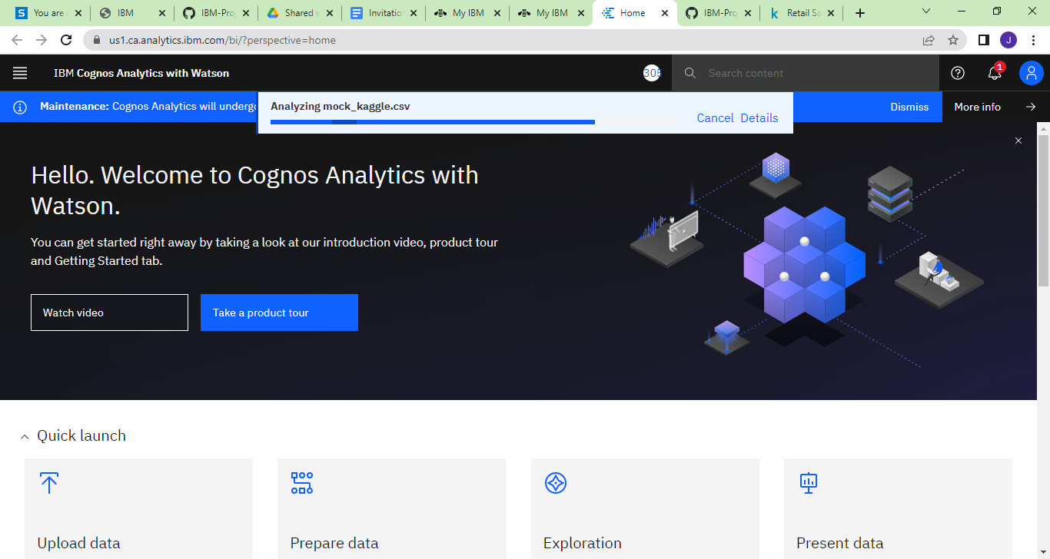

**SELECTING THE PREPARED DATA**

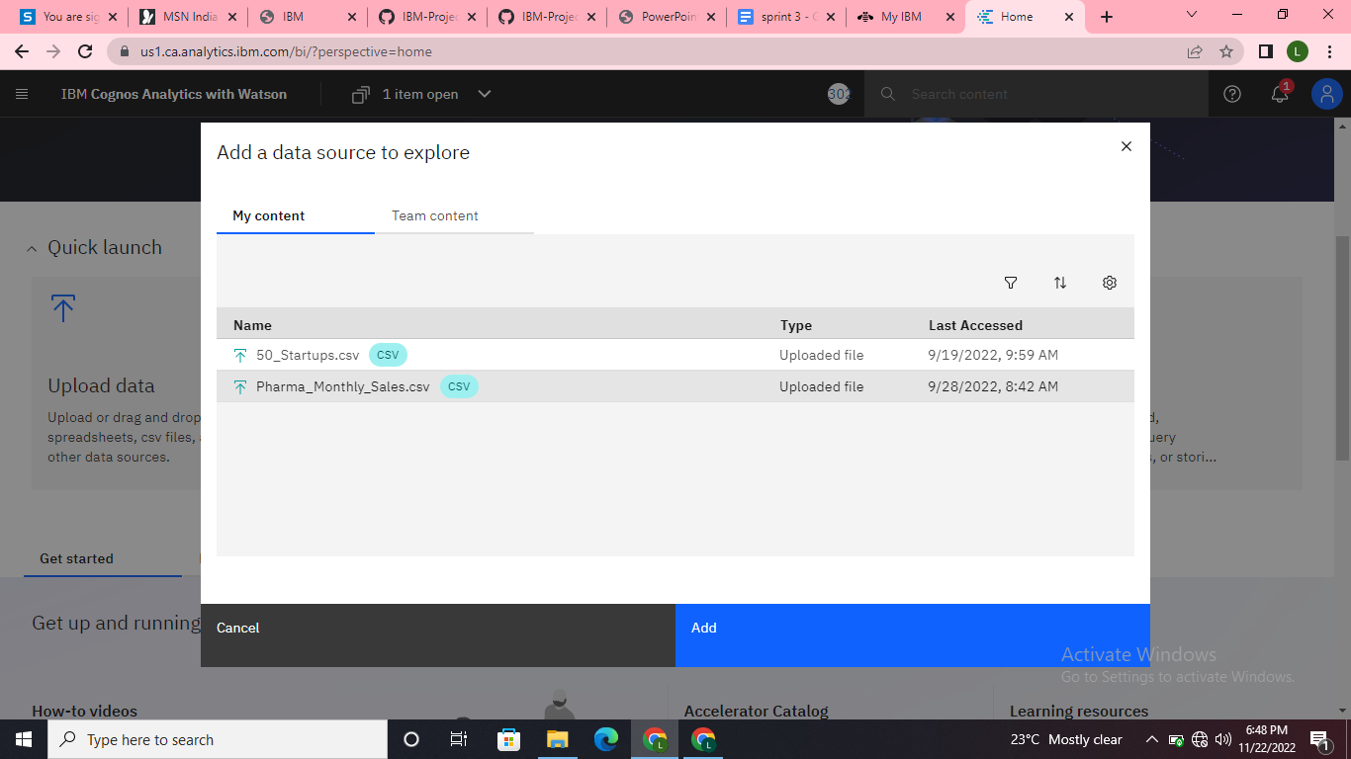

**Story Creation**

**Story 1**

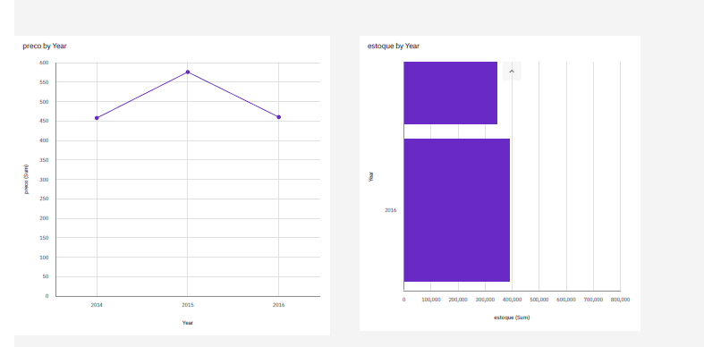

**Story 2**

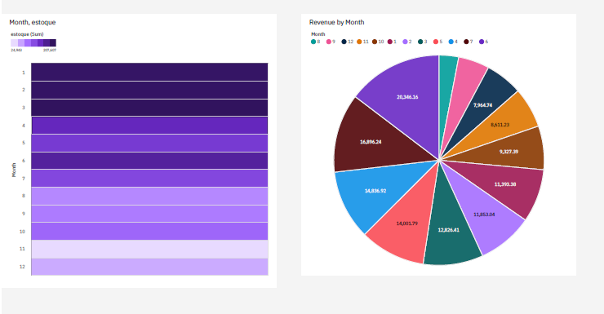

**Story 3**

